Order Of Service

Singing: Psalm 32—CW page 78

Reading: Psalm 106:40-48

Opening Hymn: TLH 32

Reading: Acts 24:22-27

Request Hymn: CW Supplement 748

Reading: Matthew 11:1-6

Sermon Hymn: TLH 367

Sermon Text: Mark 10:23-27

Doing The Impossible

Prayer

The Apostles’ Creed, TLH page 12

Holy Communion

The Lord's Prayer

The Blessing

Closing Hymn: TLH 52

* * * * * * * * * * *

Bible Study: Lambs: Wood Duck
Sheep: Proverbs 20:26-30
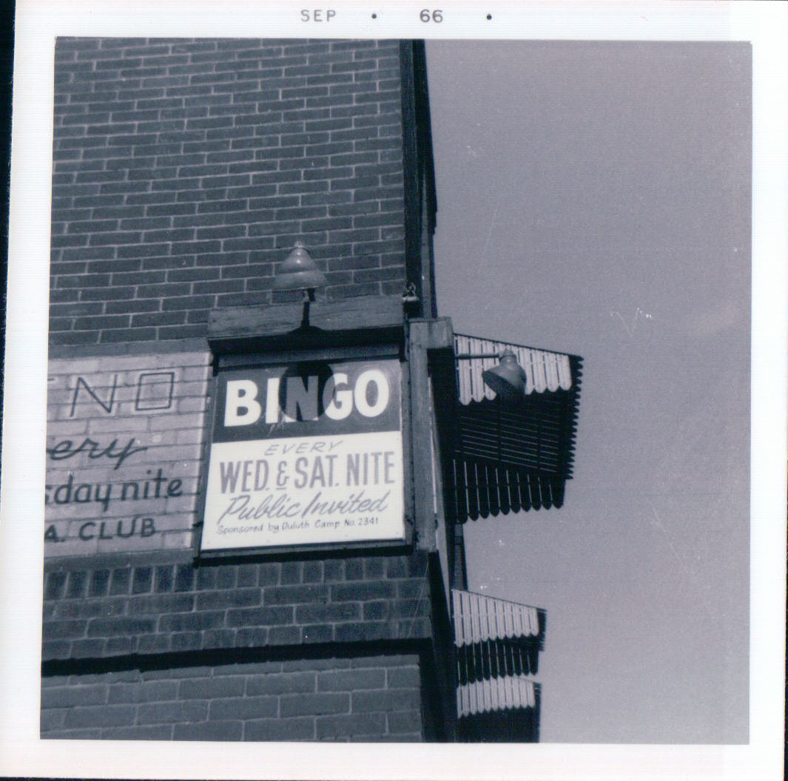

Worship Service On Sunday—Woodman Hall Duluth, MN

Water
Of
Life

27 October 2019

W A T E R O F L I F E

Independent Christian Church—Conservative Lutheran Doctrine

Worship Service: 9:30 a.m. Bible Study: 10:45 a.m.

Larry Cooper, Pastor E-Mail address:
111 N. Ridge Road lcooper@wateroflife.cc
Coon Valley, WI 54623 Web Site:
www.wateroflife.cc

* * * * * * * * * * * * * * * * * * * * * * * * * * *

Sermon Text: Mark 10:23-27

Doing The Impossible

* * * * * * * * * * * * * * * * * * * * * * * * * * *

Mark 10:23 And Jesus looked round about, and saith unto his disciples, How hardly shall they that have riches enter into the kingdom of God!
:24 And the disciples were astonished at his words. But Jesus answereth again, and saith unto them, Children, how hard is it for them that trust in riches to enter into the kingdom of God!
:25 It is easier for a camel to go through the eye of a needle, than for a rich man to enter into the kingdom of God.
:26 And they were astonished out of measure, saying among themselves, Who then can be saved?
:27 And Jesus looking upon them saith, With men it is impossible, but not with God: for with God all things are possible.

* * * * * * * * * *

Romans 7:14 For we know that the law is spiritual: but I am carnal, sold under sin.
:15 For that which I do I allow not: for what I would, that do I not; but what I hate, that do I.
:16 If then I do that which I would not, I consent unto the law that it is good.
:17 Now then it is no more I that do it, but sin that dwelleth in me.
:18 For I know that in me (that is, in my flesh,) dwelleth no good thing: for to will is present with me; but how to perform that which is good I find not.
:19 For the good that I would I do not: but the evil which I would not, that I do.
:20 Now if I do that I would not, it is no more I that do it, but sin that dwelleth in me.
:21 I find then a law, that, when I would do good, evil is present with me.
:22 For I delight in the law of God after the inward man:
:23 But I see another law in my members, warring against the law of my mind, and bringing me into captivity to the law of sin which is in my members.
:24 O wretched man that I am! who shall deliver me from the body of this death?
:25 I thank God through Jesus Christ our Lord. So then with the mind I myself serve the law of God; but with the flesh the law of sin.

